Guide for getting transaction data from Rabobank

Minimum requirements:

* Access to a Rabobank account
  + Your Rabobank card
  + Your PIN
  + A Rabo Scanner
* A web browser (preferably Chrome)

Step 1: Go to <https://www.rabobank.nl/particulieren/>

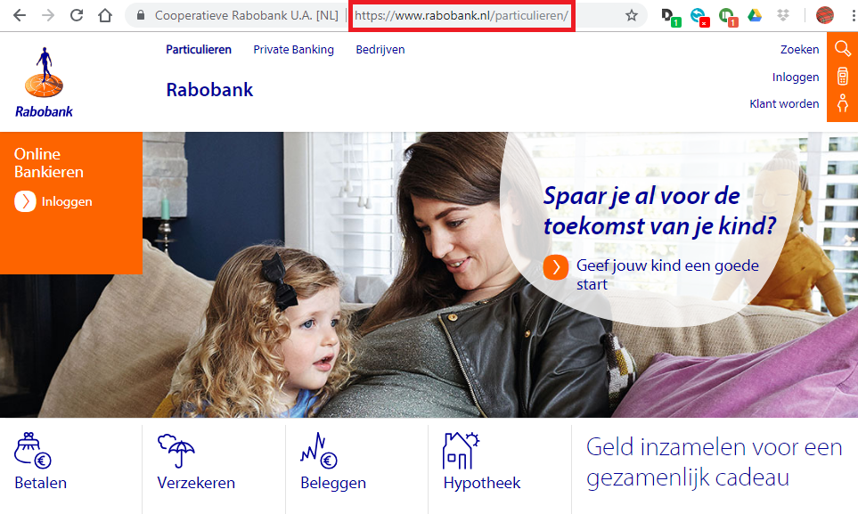

Step 2: Click on “Inloggen”

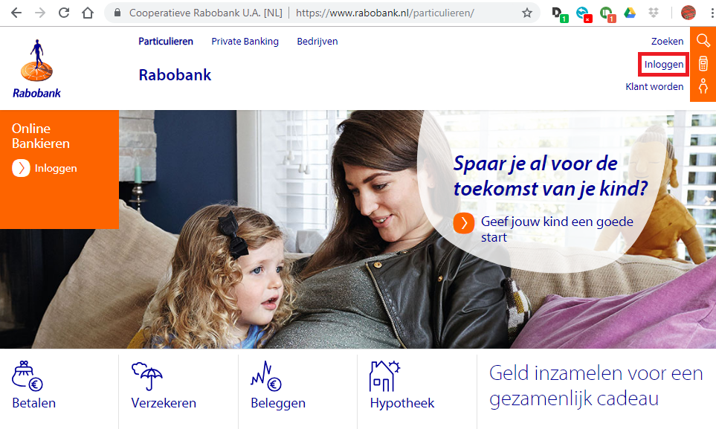

Step 3: Fill in your account number, card number and click on the “Remember me” checkbox. Then follow the instructions on the page to log in using your Rabobank card, Rabo Scanner and PIN.

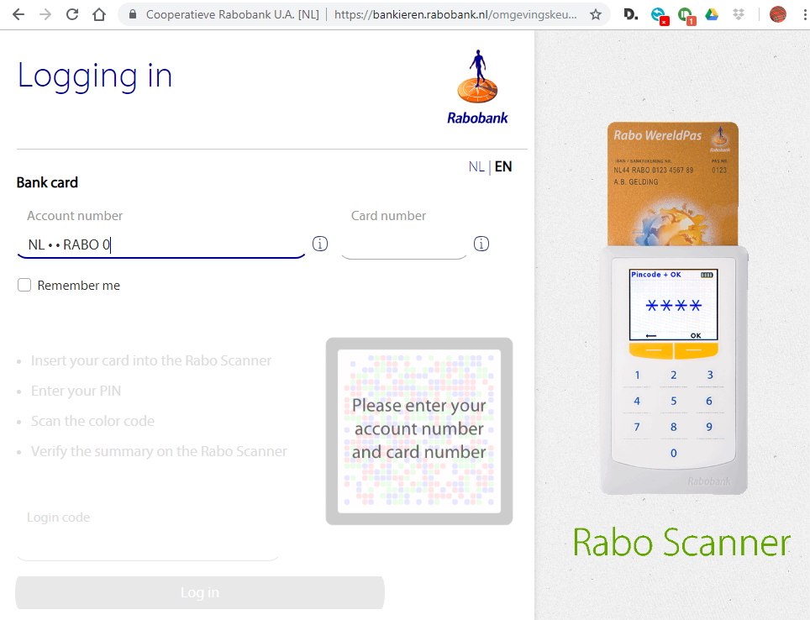

Step 4: After successfully logging in, you should arrive on the dashboard page, which should look similar to the image below. Click on your payment account:

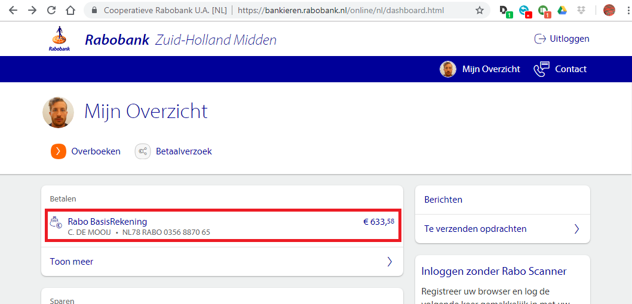

Step 5: Click on “Download transacties / afschrift”

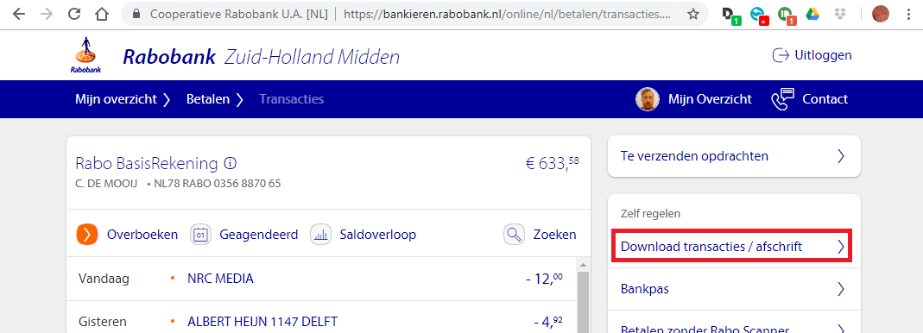

Step 6: Click on “Aangepast overzicht”

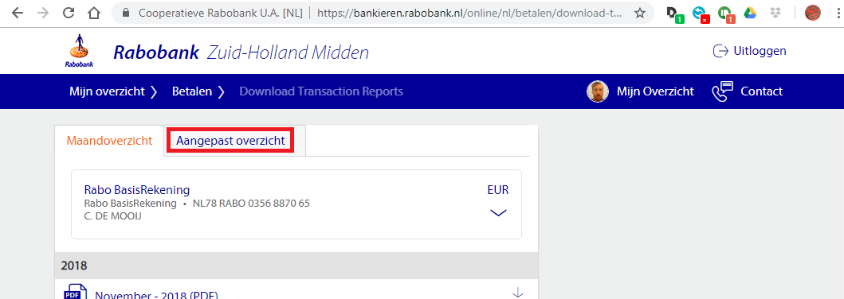

Step 7: Make sure to select the following settings:

* Downloadformaat: “CSV (.csv)”
* Rekening(en): “Alle rekeningen”
* Periode: “Specifieke datum reeks”
* Begindatum: As far back as you want to go.

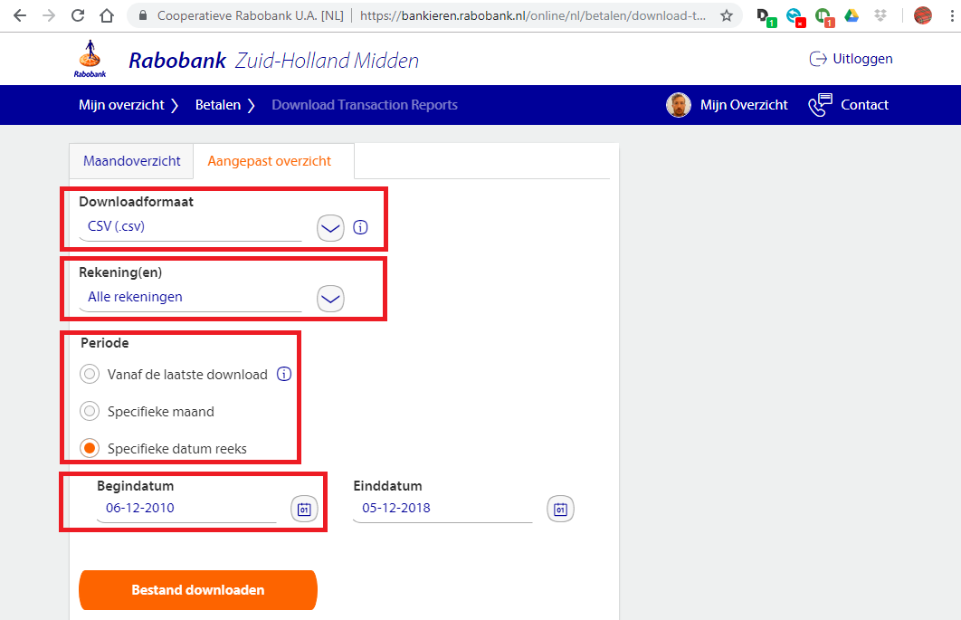

Step 8: When all the settings are set correctly, click on “Bestand downloaden”

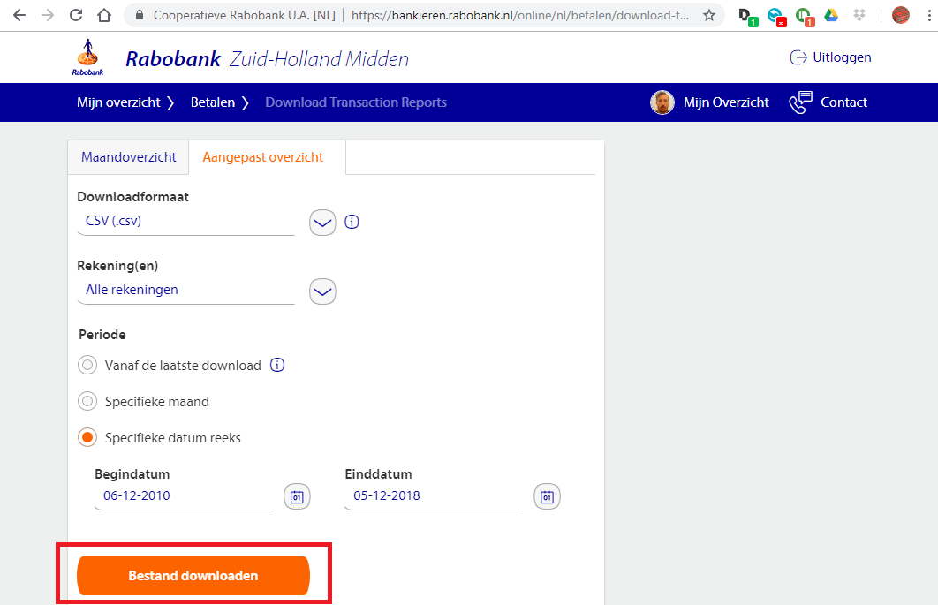

Step 9: After a few moments, a screen will appear that will ask you where want to save your CSV file. Go to the folder where the files for your website are stored. Do not save yet.

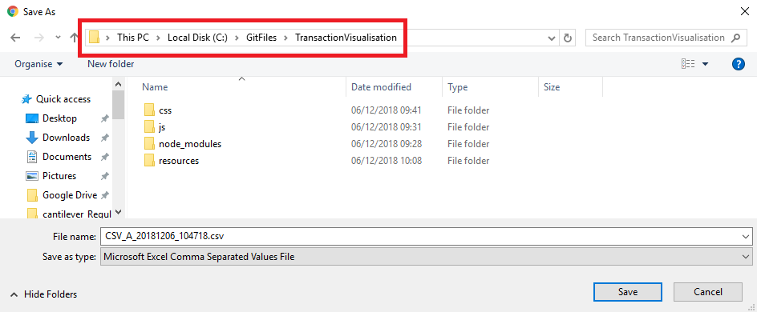

Step 10: Before you save, create a new folder and call it “data”:

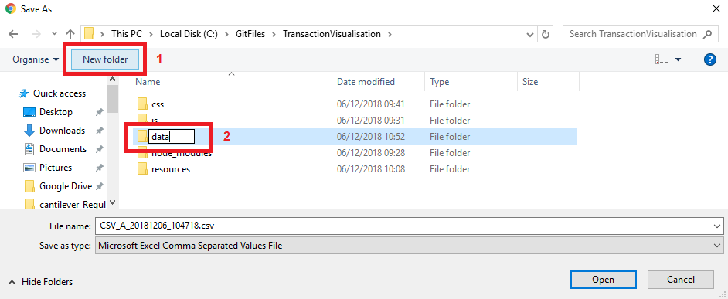

Step 11: Go to the data folder and click on “Save”

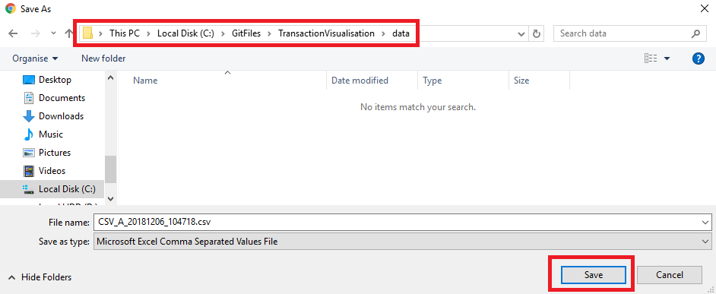

Step 12: You should now be able to open the CSV with Excel.

